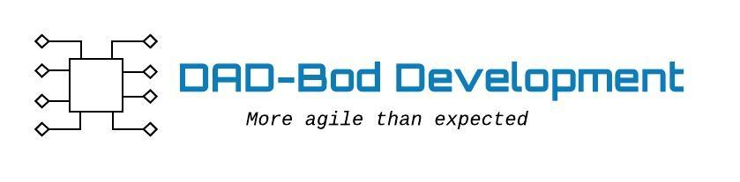

**Agile Data modeling - Entities, E-R diagram**

